**Oblíbené písničky Krajánků**









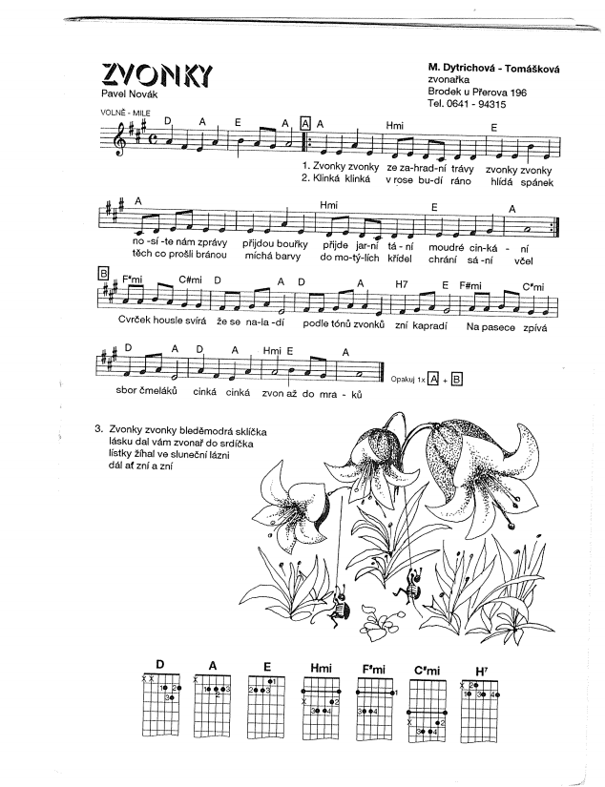

<https://www.youtube.com/watch?v=M-UedAnc2WU>

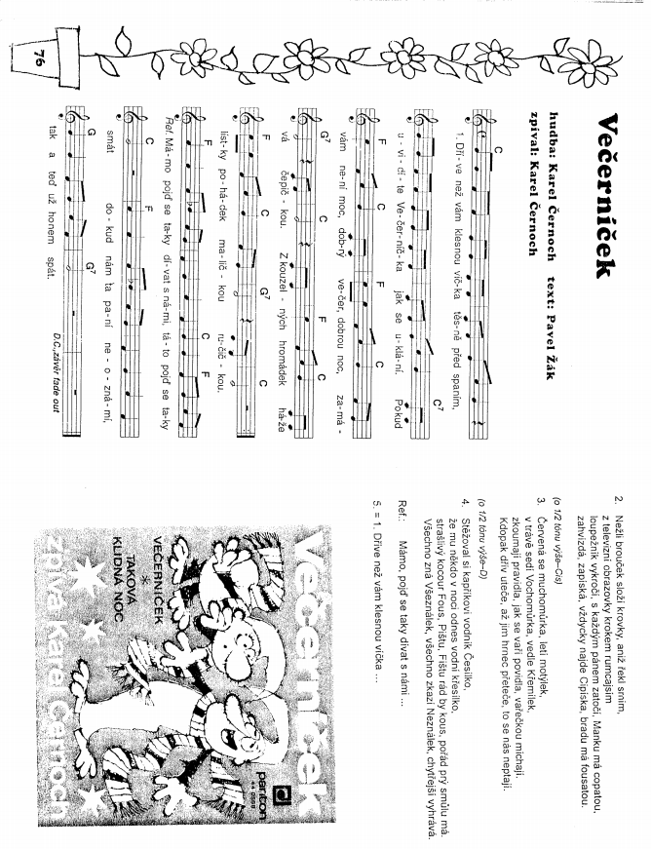

<https://www.youtube.com/watch?v=n_o3i5H-fLc>

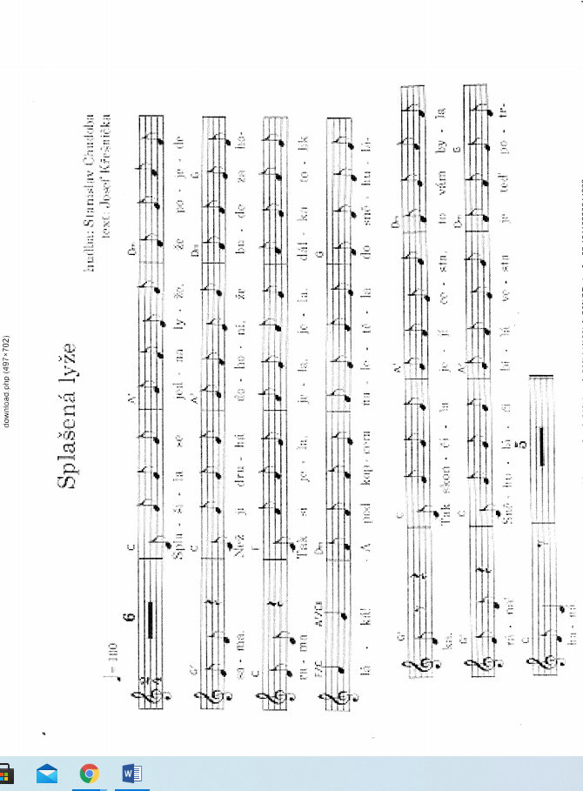

<https://www.youtube.com/watch?v=YxPk7ZdKzAE>

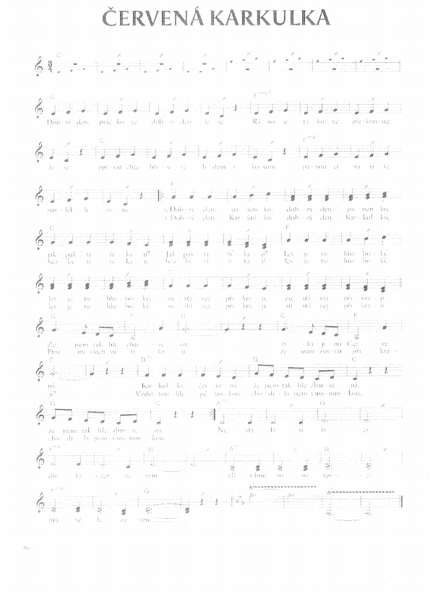

<https://www.youtube.com/watch?v=ZA5wJzkzXUg>

**Hlavně, že jsme na vzduchu**

<https://www.youtube.com/watch?v=_sIWtcNiexs>



**Mravenci**

<https://www.youtube.com/watch?v=FidcI0v6Alk>

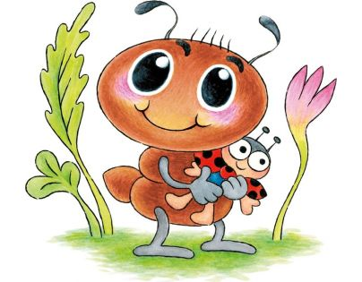

**Baby shark**

<https://www.youtube.com/watch?v=XqZsoesa55w>

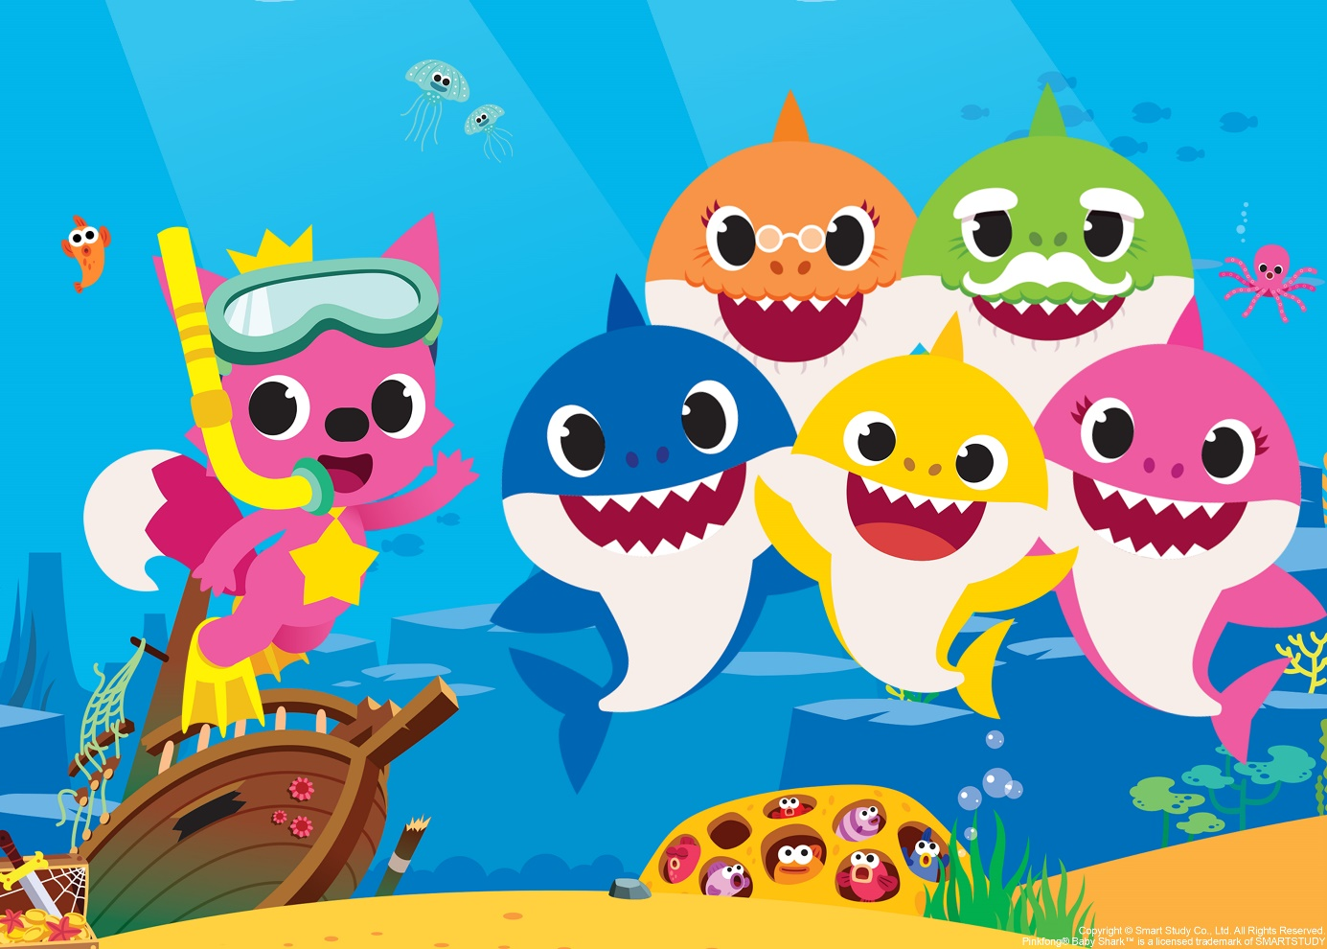

**Fíha tralala-Bum bác**

<https://www.youtube.com/watch?v=_obIgcL2gg8>

